Group Buys Q2 2024

The Group Buys program offers Members exclusive access to limited-time savings and enhanced contract value on select products and services during the active period. Reference your   
Vizient contract number   
when placing orders.

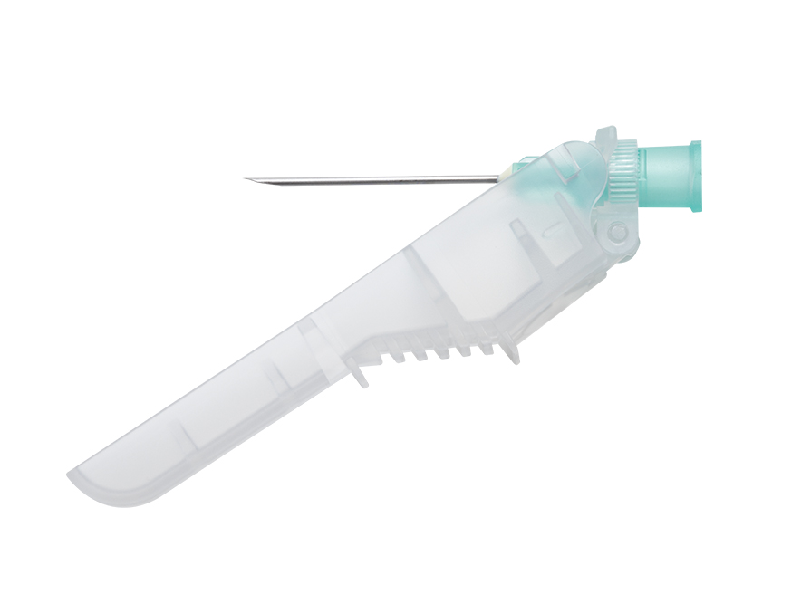

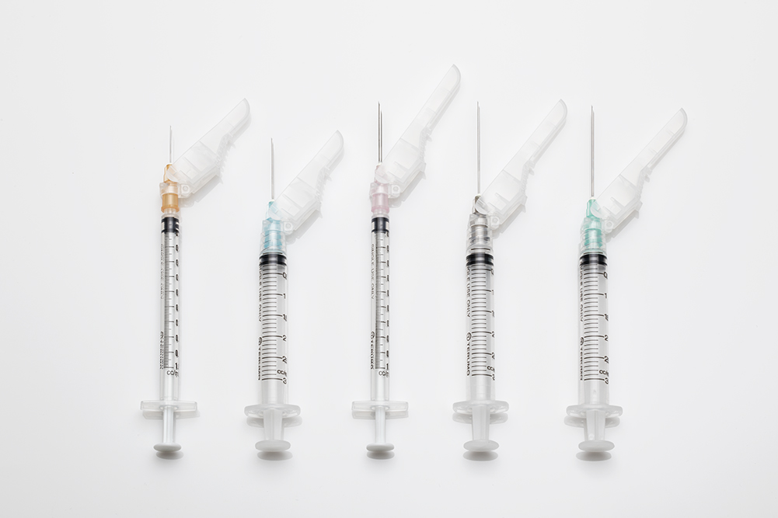

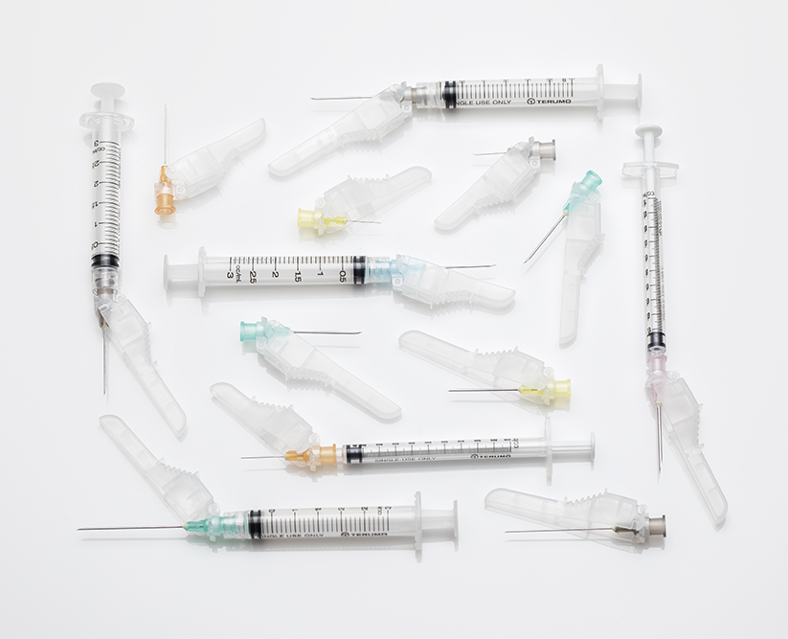

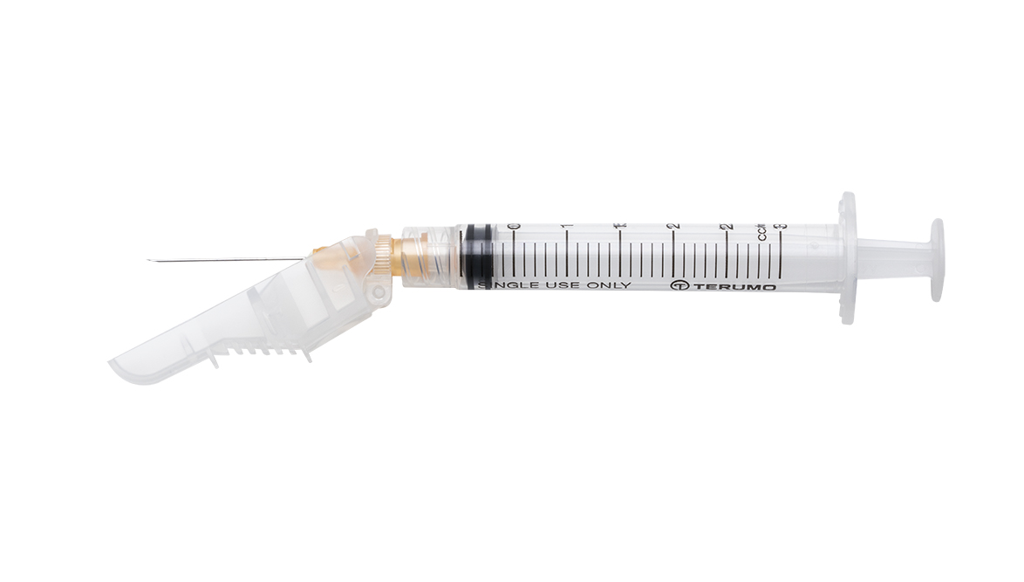

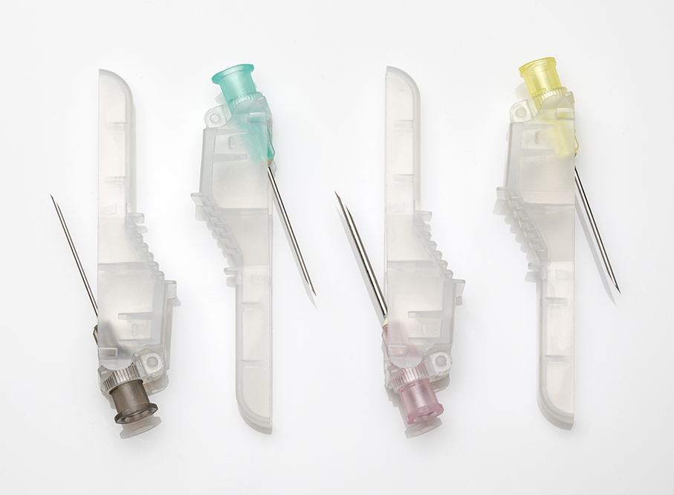

**Terumo Safety Needles and Syringes**

**Contract No.: MS7865**

**Group Buy Terms:**

**Start date:** July 1, 2024

**End date:** September 30, 2024

**Shipping guaranteed by:** All shipments must be received by Member by all PO’s must be received by September 30, 2024

**Order statement:** Orders must be placed direct or through an Authorized Distributor. Member will automatically be quoted the group buy price.

**Promotional Offer:**

5% off Tier 3 contract pricing

**Product Info:**

SurGuard®3 Safety Hypodermics

With three ways to activate and a broad range of sizes, SurGuard®3 is the industry's most adaptable safety needle. Add separate thumb and finger grips, unequalled sharpness and competitive pricing, and it’s easy to see how SG3 delivers safety, ease of use and simple standardization that make everyone comfortable.

* 3 modes of activation-thumb, fi­nger, or hard surface
* Separate ­finger/thumb grips with ridges and nonslip surfaces
* Hub and needle locks for security post activation
* Broad range of sizes
* Firm injection feel
* 10% sharper needles among major brands tested*
  + More comfortable injections for patients

*Data on file

SurGuard®3 Safety Hypodermic Needle

Packaging: 100/box, 8 boxes/case (800)

Product Code Description

SG3-1825 18G x 1" needle

SG3-1838 18G x 1 1/2" needle

SG3-2025 20G x 1" needle

SG3-2038 20G x 1 1/2" needle

SG3-2051 20G x 2" needle

SG3-2125 21G x 1" needle

SG3-2138 21G x 1 1/2" needle

SG3-2225 22G x 1" needle

SG3-2238 22G x 1 1/2" needle

SG3-2325 23G x 1" needle

SG3-2338 23G x 1 1/2" needle

SG3-2516 25G x 5/8" needle

SG3-2525 25G x 1" needle

SG3-2538 25G x 1 1/2" needle

SG3-2713 27G x 1/2" needle

SG3-3013 30G x 1/2" needle

SurGuard®3 Hypodermic Syringes with Safety Needle

Packaging: 100/box, 4 boxes/case (400)

Product Code Description

SG3-01T2516 1CC Syringe with 25G x 5/8" needle

SG3-01T2713 1CC Syringe with 27G x 1/2" needle

SG3-03L2025 3CC Syringe with 20G x 1" needle

SG3-03L2038 3CC Syringe with 20G x 1 1/2" needle

SG3-03L2125 3CC Syringe with 21G x 1" needle

SG3-03L2138 3CC Syringe with 21G x 1 1/2" needle

SG3-03L2225 3CC Syringe with 22G x 1" needle

SG3-03L2238 3CC Syringe with 22G x 1 1/2" needle

SG3-03L2325 3CC Syringe with 23G x 1" needle

SG3-03L2516 3CC Syringe with 25G x 5/8" needle

SG3-03L2525 3CC Syringe with 25G x 1" needle

**Contact info – Vizient**

**Name:** Brooke Berson

**Title:** Senior Category Manager

**Phone:** (214) 574-3377

**Email:** brooke.berson@vizientinc.com

**Contact info – Supplier**

**Name:** Patricia Confessore

**Title:** National Account Manager

**Phone:** 908-801-1928

**Email:** patricia.mcintyre@terumomedical.com

**How to request a quote**

To access the RFQ platform, or to view a list of all offers for this quarter, visit [vizientinc.com/groupbuys](https://www.vizientinc.com/groupbuys). For more information, please contact [groupbuy@vizientinc.com](mailto:groupbuy@vizientinc.com).